

**DSA (Data Structure and Algorithms)**

**Assignment # 4**

**Semester**: 3rdSemester

**Section**: C

**Submitted To:**

**Shahid Iqbal**

**Submitted By:**

**Name**: Abdul Ahad

**Roll No**: 22-CS-071

**Question 1:**

Prepare the Arithmetic Expression Tree from the following Arithmetic

formulas and then traverse each Tree in Post-Order and Pre-Order format.

1. B + C + D + E + F + G

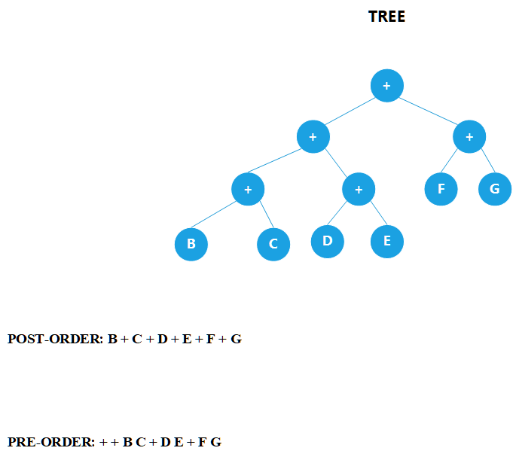

1. A + B * (C / (D / (E + F) – G))

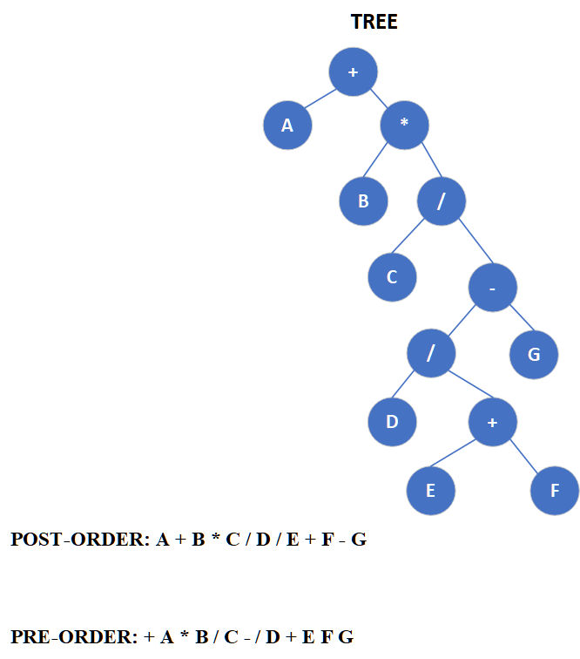

Q-2

Construct Binary Search Tree and Apply using following Key Values.

14, 4, 6, 13, 15, 11, 5, 2, 9, 3, 8, 10, 12, 7, 16

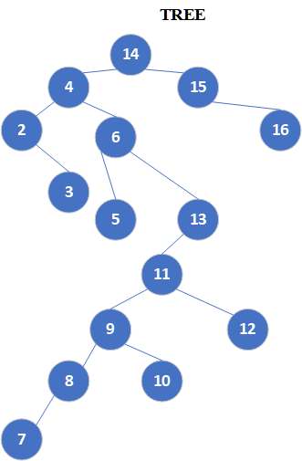

a. Delete 3 from BST (Redraw Tree after deletion)

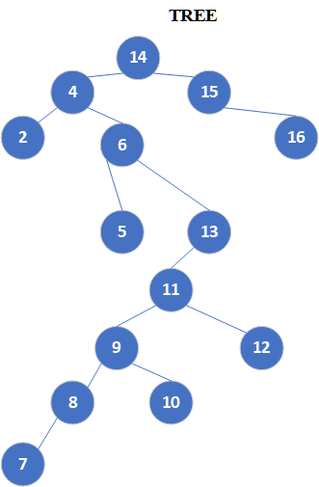

b. Delete 15 from BST (Redraw Tree after deletion)

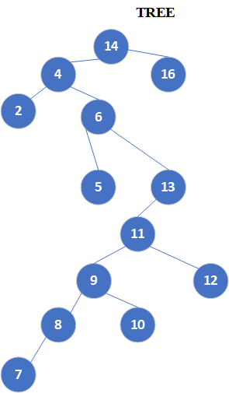

c. Delete 6 from BST (Redraw Tree after deletion)

